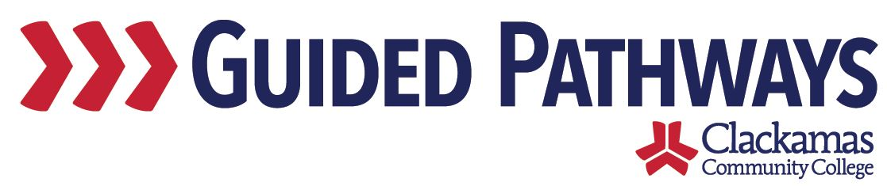
Guided Pathways Leadership Taskforce
Meeting Notes
March 2, 2020, 2:00–3:30 p.m.

- Follow up on previous commitments and updates
Commitments were reviewed.
- The communication plan for the EFA launch has been taken care of
- Dustin and Tara need further clarity around the document for Student Services staff around the EFA launch

- Data Indicators Discussion, Continued
Lisa Anh wasn’t here at the last taskforce meeting, but she connected with Max and Carol, who updated her on the discussions the group had. Lisa Anh discussed the questions we want to keep in mind to make sure we are centering the student experience in our guided pathways efforts. She showed on the wall the questions that were discussed at the last meeting. The most votes at the last meeting were for: 1, 5, 6, 9, 10, 14, and 19. There was feedback that 8 and 5 could be combined, as well as 19 and 20.

Lisa Anh asked for observations. It was noted that we don’t have any in the advancement stage. We focus quite a lot on connection and entry phases, and not as much on progress/completion and advancement phases.

The taskforce broke into small groups for a discussion activity. Key takeaways from the groups:
- Question 22 – how can we ask that question in a way that gets at equity gaps?
- Question 23 – what is the purpose of looking at that? Unless it’s looking at an equity gap?
- Question 26 – wording is odd – very few courses that count toward the junior level, but may count toward the major
- Instead of focusing only on confidence, we should ask questions to see if students are knowledgeable
- Question 1 – yes, that is applicable
- Some of these questions feel like they are targeted toward full-time students
- Question 10 – not all programs need over 100-level math – depends on the program
- Stage 3 – add question about being on-path vs. off-path
- Similarities between 17 and 24 – thinking about connecting current students in their programs to whatever their next steps are – also connected to 5
- Question 6 – we have a tool, but the tool is difficult for students to find and it doesn’t answer the question of the cost at the program-level – include what the time/cost will be for part-time students as well
- Question 9 – percentage of students who meet with an advisor and have a full program plan – how likely are students able to take those classes they need in their second year so that they are able to transfer – likelihood is about 15%

Lisa Anh said that the goal with this exercise is to think about these questions as we do our guided pathways work to really center the student experience. These sets of questions help us reframe that thinking around the work we’re doing.

- Early Momentum Metrics Report
Mark Kremkow and Lauren McGuire shared the Early Momentum Metrics report. This report looks at student success in multiple ways. There will be text attached that provides definitions. The report is printer-friendly. Version 2 will be more focus on CCC-specific data, including EFAs. If there are pieces you’d like to see included in version 2 of the report, let Lisa Anh, Lauren, or Mark know.

To access the report, visit: myClackamas > Reports > Institutional Reports > Institutional Internal Reports > Early Momentum Metrics

- Change Model Update
We are holding off on adopting a change model.

- EFA Web Pages
Kim Crane joined the meeting to provide an update on the EFA web pages. New pages are being created for each EFA. The website navigation experience is being adjusted. There will be a new landing page that will list all of the EFAs. The website will still have the search bar and alphabetical list of programs, but will now also have EFAs listed. The plan is to have the EFA websites live by April 13. Phase 1 will have basic information and phase 2 will include wish list items. The content is based on the EFA maps with some additional copy and photos. That content will need to be signed off by the end of March to have it up in time for the April deadline. Accessibility testing is being performed. Program pages won’t be altered at this time. An idea for phase 2 would be to include the cost of the program.

There will opportunities for people to provide feedback. The team is trying to get in front of students to get their feedback, including going through David Green to get FYE student feedback and Jaime Clarke for High School Connections student feedback. There will also be updates through College Council and other shared governance meetings.

- Stakeholder Matrix Revisit
Max brought up the stakeholder matrix on the screen. This was last reviewed as a group on March 4, 2019. As we look forward to next year, we want to have a conversation. The point isn’t necessarily to get everyone at the top level of engagement. Which groups are we able to move on the axis after a year of engagement? Max made updates to the matrix on the screen. Max and Carol will send out the matrix to the taskforce.

- Workgroup updates
No updates provided.

- Review commitments and next steps
Commitments and next steps were reviewed. The next Guided Pathways Taskforce Meeting is on Monday, April 6, 2:00–3:30 p.m. in B240.

